Zwamy Viewlists and Categories

7/19/2013

# Hierarchy

There is a 3 level hierarchy for pictures within Zwamy which looks like:

Category

Viewlists

Images

An image can belong to multiple viewlists and a viewlist can belong to multiple categories.

For example

Fine Art (*category*)

Best of the Impressionists (*viewlist*)

Water Lillies – Monet (*image*)

Bridge – Monet (*image*)

13th Century *(viewlist*)

Picture 1 (*image*)

Picture 2 (*image*)

Rembrandt *(viewlist*)

Rembrandt picture 1 (*image*)

Rembrandt picture 2 (*image*)

Top Lists (*category*)

World’s most popular art (*viewlist*)

Water Lillies – Monet (*image*)

Rembrandt picture 1 (*image*)

Best of the Impressionists *(viewlist*)

Water Lillies – Monet (*image*)

Bridge – Monet (*image*)

Introduction to Zwamy *(viewlist*)

Introduction image 1 (*image*)

Introduction image 2 (*image*)

Introduction image 3 (*image*)

There are no technical limits to the number of categories, viewlists or images or how they are named. However the content team may decide to impose limits on the number of categories or create naming conventions as they see fit.

For each device the Zwamy server keeps track of which viewlist is active for every device and which specific image within the viewlist is currently being displayed on the device. Every device must have an active category, viewlist and image. Initially the default category is “Top Lists”, the default viewlist is always set to a viewlist entitled “Introduction to Zwamy”.

# Selecting viewlists and categories

Users select viewlists within categories using their smartdevice.

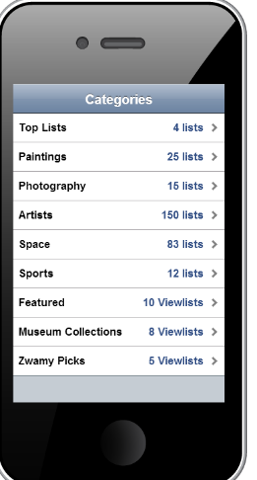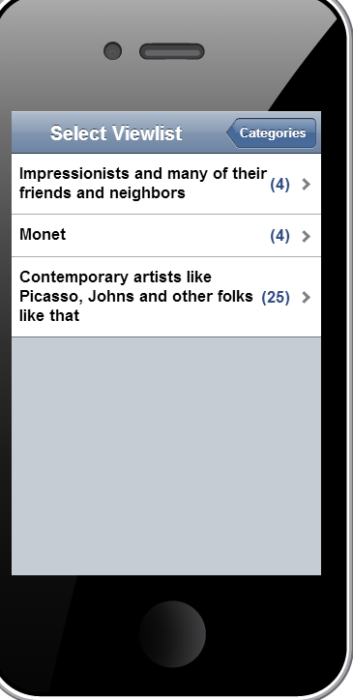Using the Zwamy menu the user can choose “Select Viewlist”. The system then displays the viewlists within the current selected Category: It is important to note that the user always has a selected category (even when they have not picked one explicitly, in which case it is the default category).

The user can then choose a viewlist for display. The user can change categories by selecting the “Categories” button on the viewlist screen. When the user selects a Category by touching a category the UI immediately switches to the viewlists for that category.

This is done to simplify the user experience and allow users to quickly change viewlists without having to explicitly first choose a category every time which would require extra clicks. So if a user is looking at viewlists with the Top Lists category and they want to select a new viewlist, when they click “Select Viewlist” we immediately show them the viewlists in the “Top Lists” category. They can then change categories if they like. We may change this based on user reaction.